**Waste Detection Under Water**

**Problem Statement:**

Automated Underwater Waste Detection System

**Background:**

Underwater waste pollution poses a significant threat to marine ecosystems, biodiversity, and human health. There is a need for an automated, efficient, and accurate system to detect and monitor underwater waste.

**Objective:**

The goal is to develop an advanced automated system for detecting and monitoring waste accumulation underwater. This system should be capable of identifying various types of waste materials (e.g., plastics, metals, organic matter) at different depths and provide actionable insights to facilitate timely and effective waste management.

**Description:**

This project addresses the issue of growing underwater waste in oceans or seas. It offers three solutions:

1. YOLOv8 (You Only Look Once version 8) Algorithm-based underwater waste detection
2. A rule-based classifier for aquatic life habitat assessment
3. A Machine Learing Model for water classification as fit for use or not.

**What is YOLOv8 ?**

YOLOv8, or You Only Look Once version 8, is a state-of-the-art real-time object detection algorithm that has taken the [computer](https://yolov8.org/what-is-yolov8/) vision world by storm. Developed by Alexey Bochkovskiy in 2020, YOLOv8 builds upon the success of its predecessors, YOLOv5 and YOLOv7, to offer even greater accuracy, speed, and efficiency.

## **Why Should I Use YOLOv8?**

YOLOv8 is a state-of-the-art object detection model that has quickly become a favorite among developers and researchers. It’s known for its impressive accuracy, speed, and ease of use.

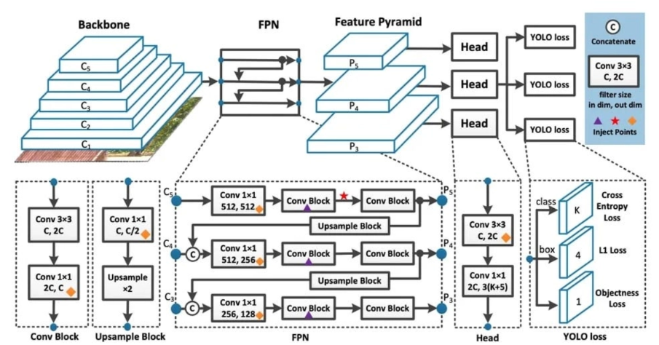Here are just few reasons:

### **1: High Accuracy**

YOLOv8 consistently outperforms other **[object detection models](https://yolov8.org/desktop-model-planes-yolov8/)**on popular benchmarks like COCO and Roboflow 100. This means that you can be confident that YOLOv8 will accurately identify objects in your images and videos.

### **2: Speed**

YOLOv8 is a single-stage detector, which means that it can detect objects in an image in a single pass. This makes it much faster than two-stage detectors, which require multiple passes. This speed is especially important for real-time applications, such as self-driving cars and drone surveillance.

### **3: Ease of Use**

YOLOv8 comes with a well-documented Python API and a user-friendly command-line interface ([CLI](https://en.wikipedia.org/wiki/Command-line_interface" \t "https://yolov8.org/what-is-yolov8/_blank)). This makes it easy to get started with YOLOv8, even if you’re not a [computer](https://yolov8.org/what-is-yolov8/) vision expert.

### **4: Versatility**

YOLOv8 can be used for a variety of tasks, including object detection, instance segmentation, and image classification. This makes it a versatile tool that can be used for a wide range of applications.

**Features:**

* Can detect underwater waste based on input images.
* Classifies water as potable or not based on chemical properties of water.
* Classifies water as habitual for aquatic life or not.

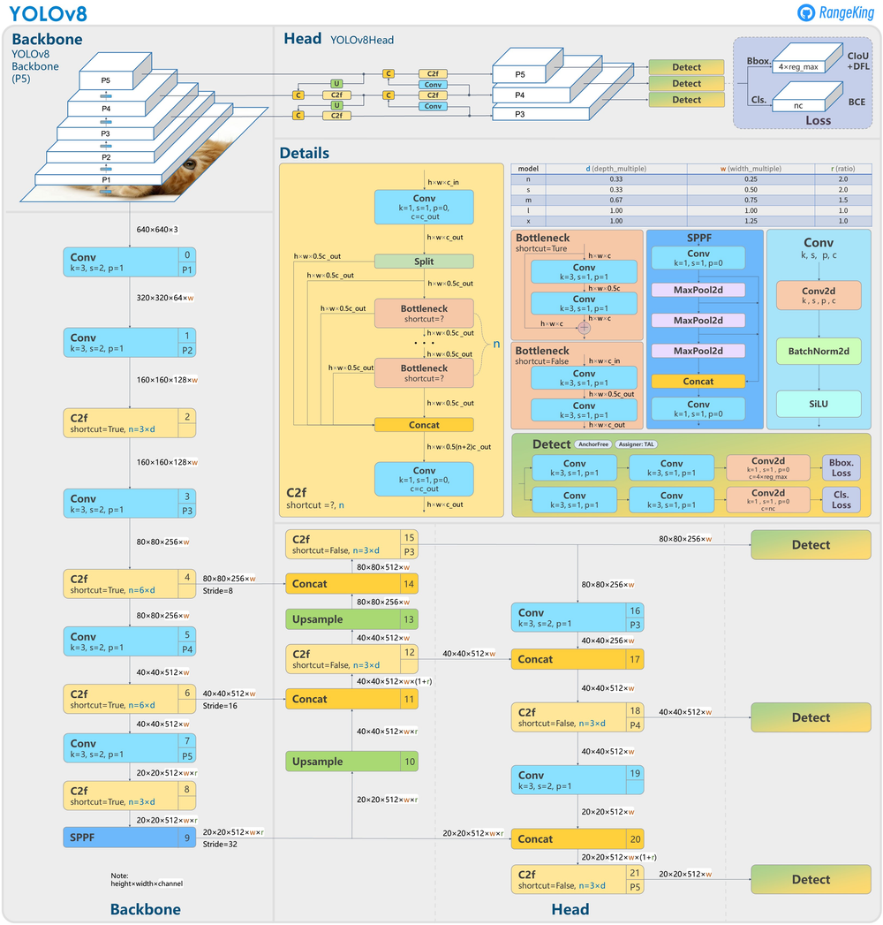**Architecture of YOLOv8:**

**Scope:**

1. **Data Collection:**

* Deploy underwater drones, remote sensing technologies, or sonar systems to capture images and videos of the underwater environment.
* Collect data under various conditions, including different water depths, clarity levels, and flow rates, to ensure comprehensive coverage.

1. **Data Processing:**

* Implement advanced image processing, computer vision, and machine learning algorithms to analyze the collected data.
* Detect and classify different types of waste materials, distinguishing between natural debris and anthropogenic waste.

1. **Real Time Monitoring**

* Develop a real-time monitoring system that continuously scans the underwater environment.
* Generate alerts and detailed reports on the presence and types of underwater waste detected.

**Significance:**

This project aims to significantly enhance the efficiency of underwater waste detection and management efforts, thereby reducing the environmental impact of underwater pollution, protecting marine life, and contributing to the sustainability of aquatic ecosystems.

**References:**

[https://www.researchgate.net/publication/356793137\_Trash\_Detection\_on\_Water\_Channels](https://www.researchgate.net/publication/356793137_Trash_Detection_on_Water_Channels" \t "_blank)

[https://yolov8.org/what-is-yolov8/#:~:text=YOLOv8%2C%20or%20You%20Only%20Look,accuracy%2C%20speed%2C%20and%20efficiency.](https://yolov8.org/what-is-yolov8/" \l ":~:text=YOLOv8, or You Only Look,accuracy, speed, and efficiency." \t "_blank)